34.94: Light passing straight through the lens:
a)

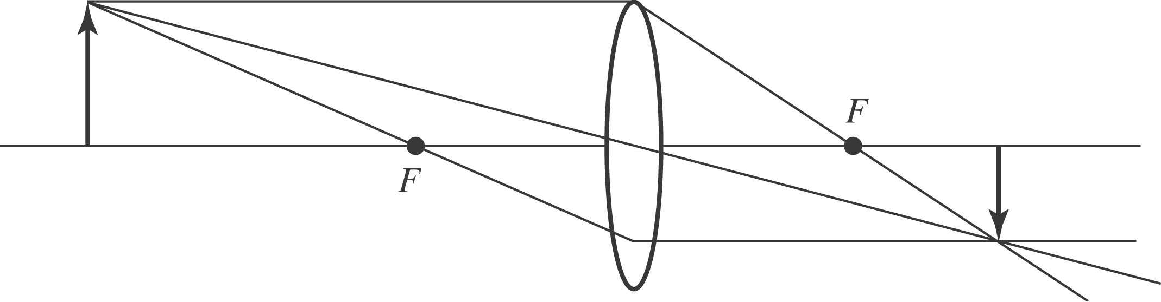

b) 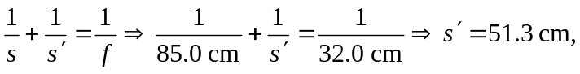 to the right of the lens.
c) The image is real.
d) The image is inverted.
For light reflecting off the mirror, and then passing through the lens:

a)

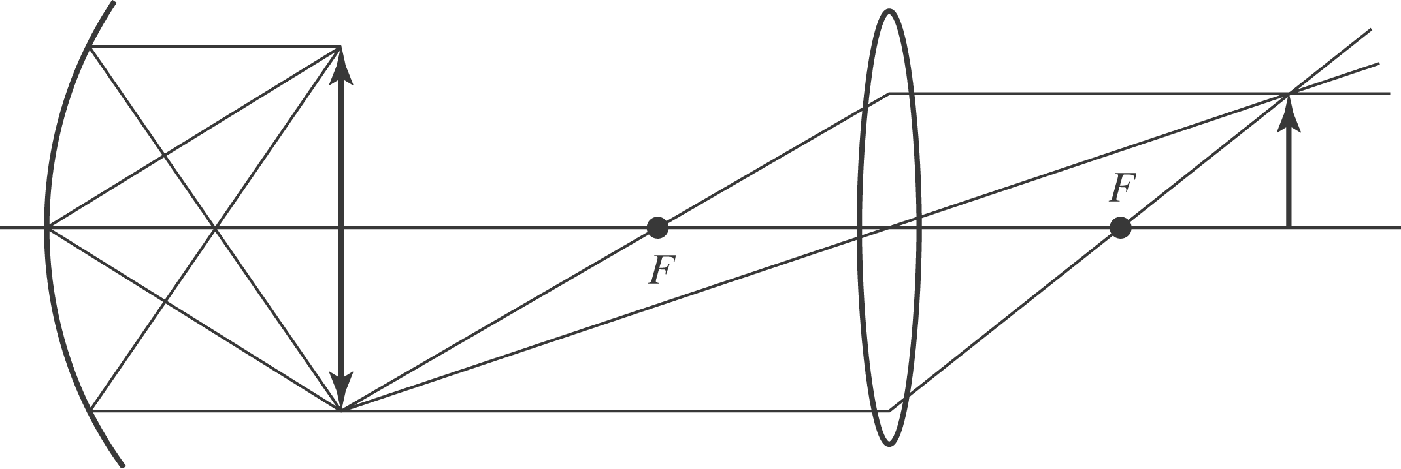

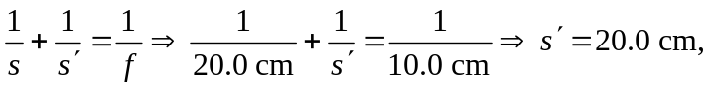 so the image from the mirror, which becomes the new object for the lens, is at the same location as the object. So the final image position is 51.3 cm to the right of the lens, as in the first case above.
c) The image is real
d) The image is erect.

